What Is it? Yates Blood & Bone Meal contains meat meal which is a high source of organic Nitrogen.
It is suitable for a wide range of plants including vegetables, flowers, fruit trees, lawns as well as trees and shrubs.
Yates Premium Blood & Bone can be used as a general fertiliser to promote healthy growth in most fruiting and or flowering crops. Yates Blood & Bone Meal is organic- based, which also makes it beneficial for general soil health and structure, while increasing microbial and earthworm activity.

Specific Product Benefits Contains 100% pure Blood & Bone Meal
Encourages beneficial microbial activity
Contains organic-based slow release nutrients

How Does It Work? Yates Blood & Bone Meal is suitable for a wide range of plants including vegetables, flowers, fruit trees, lawns and shrubs.

Yates Blood & Bone Meal contains:
• Nitrogen for healthy leaf growth
• Phosphorus for strong root development
• Potassium for flower and fruit development
• Calcium—essential for cell wall structure and strength

Pack Sizes Available 1 Tonne Bulk Bag

Typical Analysis
%w/w
Total Nitrogen (N) 7.1
Total Phosphorus (P) 5.6
Total Potassium (K) 0.2
Total Sulfur (S) 0.2
Total Calcium (Ca) 12

Suggested Application Rates
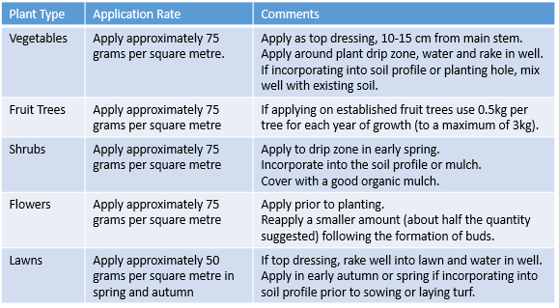

Note: The above is a general guide only, application rates will vary according to local soil conditions and would therefore depend on a comprehensive soil analysis.

Measurement Guide: 1 full cup is approximately 150g

Application Precautions The dust from this product may irritate eyes and skin. Avoid contact with eyes and skin. Avoid inhaling dust. Wash hands after use.
FOR EMERGENCIES ONLY, CALL AUSTRALIA 1800 033 111 (ALL HOURS).
NOTICE: NOT TO BE FED TO SHEEP, CATTLE, DEER, ALPACAS, GOATS OR OTHER RUMINANT ANIMALS.
PRECAUTION: PETS MAY BE ATTRACTED TO THIS PRODUCT. IF CONSUMED, THIS PRODUCT MAY BE HARMFUL TO PETS, ESPECIALLY DOGS. SHOULD DOGS CONSUME THIS PRODUCT, CONTACT YOUR VETERINARY SURGEON IMMEDIATELY. AVOID HEAPING FERTILISER AS THIS MAY ATTRACT DOGS. CULTIVATE INTO SURFACE AND WATER WELL TO HELP PREVENT DOGS CONSUMING. STORE AWAY FROM DOGS. STORE IN A DRY PLACE WITH BAG CLOSED TO PREVENT DETERIORATION.

Safety, Health & Safety Directions
Environment Although non-toxic, KEEP OUT OF REACH OF CHILDREN.
Store in a dry place. Ensure bag is sealed tightly after use,
so product does not dry out.
Poisons Schedule: No adverse health effects expected if the product is handles in accordance with the Safety Data Sheet and the product label. See Safety Data Sheet for further details.
Hazardous Substances: Based on available information, not classified as a hazardous substance.
Dangerous Goods: Not classified as Dangerous Goods
Waste Disposal: Refer to local government authority for disposal recommendations.
Environmental Warning: Avoid contaminating waterways. For further information, consult the Safety Data Sheet.

For more information refer to www.ocp.com.au or Yates Sales Support 1300 132 153

