What Is it? MoisturAid is a granular wetting agent for turf, nurseries, potting mix, landscaping, forestry, councils, estate gardens, flowers and any situation where water repellent soils are not allowing water and nutrient to get into the root zone. This slow release granular formulation dramatically improves the wettability & water holding capacity of soils and potting mixes.

Specific Product Benefits MoisturAid is a granular wetting agent suitable for a broad range of horticultural applications.
MoisturAid dramatically improves the wettability & water holding capacity of soils and potting mixes.
. MoisturAid overcomes hydrophobic (water repellent) and water logging problems, eliminates dry spots, improves drainage, optimises water and fertiliser availability, reduces stress and increases plant survival rates.
MoisturAid is a slow release granular formulation with the active ingredient made available over an extended period of time, usually up to six months. This is not the case with liquid wetting agents which require frequent repeat application.
Also unlike liquid wetting agents, there is no need for irrigation immediately after an application.
MoisturAid is easily spread over the surface or incorporated into the soil or potting mix.
MoisturAid saves time, water and plants

How Does It Work? MoisturAid undergoes a unique manufacturing process which impregnates a liquid wetting agent into the chosen carrier material (a fossilised sponge). This process makes the active ingredient available over a much longer period of time, usually up to six months. The wetting agent is released in the presence of irrigation or rainfall. MoisturAid works by decreasing the natural surface tension of applied water to ensure irrigation water or rainfall filters through to the root zone.
Pack Sizes Available 25kg

Suggested Application Rates Potting mix or soil incorporation – 1 kg per cubic metre at time of blending
Topdressing:
200mm pots 5 grams (1 heaped teaspoon);
250mm pots 10 grams (2 heaped teaspoons);
300mm pots 13 grams (1 heaped dessert spoon);
400mm pots 25 grams (2 heaped dessert spoons);
500mm pots 35 grams (3 heaped dessert spoons)
Planter Bags – 1 gram per litre of potting mix (eg. 45 litre bag = 45 grams)
Landscaping – 30 grams per square metre for heavy soils; 60 grams per square metre for sandy soil

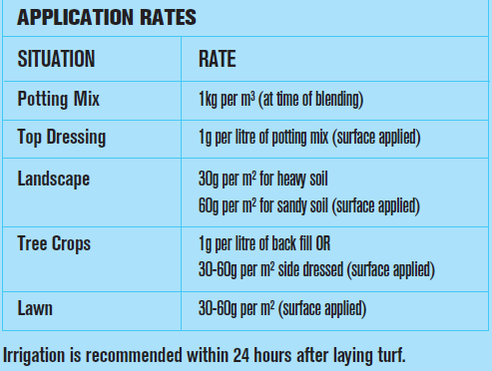

Application Precautions The dust from this product may irritate eyes and skin. Avoid contact with eyes and skin. Avoid inhaling dust. Wash hands after use.

Safety, Health & Safety Directions
Environment Although non-toxic, KEEP OUT OF REACH OF CHILDREN.
Store in a dry place. Ensure bag is sealed tightly after use,
so product does not dry out.
Poisons Schedule: No adverse health effects expected if the product is handles in accordance with the Safety Data Sheet and the product label. See Safety Data Sheet for further details.
Hazardous Substances: Based on available information, not classified as a hazardous substance.
Dangerous Goods: Not classified as Dangerous Goods
Waste Disposal: Refer to local government authority for disposal recommendations.
Environmental Warning: Avoid contaminating waterways. For further information, consult the Safety Data Sheet.

For more information refer to www.ocp.com.au or Yates Sales Support 1300 132 153

